GENIUS CHARGE CONTROLLER
INSTALLATION AND USE MANUAL FOR CIVIL APPLICATIONS

CONTENTS

1 GENERAL INFORMATION 2
2 GENERAL NOTES ON APPLYING AND INSTALLING GENIUS 3
3 ELECTRICAL INSTALLATION 3
USE OF THE MANUAL 3
4 CIVIL OR 24-HOUR A DAY USE 4
5 NOCTURNAL, SOLAR STREET LIGHT 9
6 DISPLAY VERSION 14
7 EXTERNAL PERIPHERALS 18
8 TECHNICAL SPECIFICATIONS 19

GENIUS CHARGE CONTROLLER
INSTALLATION AND USE MANUAL - CIVIL APPLICATIONS

1 GENERAL INFORMATION

Thank you for choosing a GENIUS charge controller for photovoltaic modules. This is the most reliable and versatile product that the market can offer.
The GENIUS range is available in 4 versions: 15 amps, 30 amps with and without display and has been designed for use in domestic systems, solar street lights, rural homes, telecommunications systems and anything else managed in any photovoltaic system.

GENIUS can control the battery charge and monitor it by means of an algorithm that gives it a longer average life than traditional charge controllers. It can also manage loads that are voltage controlled or which are controlled according to the State Of Charge (SOC) of the battery. Protection is provided by a microprocessor inside GENIUS.

OPERATING PRINCIPLES

GENIUS is a charge controller for photovoltaic modules that can control and manage the charging and discharging of one or more batteries connected to it. GENIUS is built entirely solid state (without relays) and it contains the blocking diode that prevents reverse current flow at night. Its powerful microprocessor that supervises all the functions can meet all the widely differing needs of the system, so that it can be used in domestic systems, for telecommunications systems and for isolated mountain cabins. GENIUS is ideal for public lighting and for solar street lights, including those with adjustable settings, for managing night-time loads and for meeting the most disparate demands that a system might make.
The controller has 6 large terminals that can accommodate cables measuring in total 16mm2 or even more if suitable cable terminals are used.
The controller is secured by means of 4 slots to a tough aluminium base that also acts as a heat sink. The 3-LED display shows the key information on the system whilst the screen-printed messages on the container explain its meaning clearly and in detail. GENIUS 15D or 30D versions are equipped with a 32-character LCD display for a complete view of the system parameters and also in order to enable some of them to be easily modified by the user.
The controller is of the serial type that controls the final charge by means of PWM pulses. An internal temperature probe monitors the ambient temperature and compensates the voltage thresholds. GENIUS also has an RS 232 serial output to transmit data via cable or GSM modem. It has an output for external display to which a cable of up to 10m in length can be connected and the internal parameters can be modified. A peripheral is also provided that has 3 logic outputs for monitoring the charge status of the batteries or for giving enabling signal to external power units or other generators. The system-fault alarm is assigned to a dedicated outlet. GENIUS can also be connected to an external temperature probe that measures the actual temperature of the battery chamber for high-precision monitoring of end-of-charge voltage. An external shunt can be connected that can read currents from and to the battery up to 100 amps, which is therefore much greater than the maximum capacity of the controller. It has a ‘4-wire’ function that enables battery voltage to be read directly at their terminals. The “low power” function that enables the LEDs to be switched off to reduce consumption is also important as is the option of choosing between the installer menu and the user menu. GENIUS is the perfect answer to all your photovoltaic system’s needs!

2 GENERAL NOTES ON APPLYING AND INSTALLING GENIUS

- It can be used only with 12 or 24V batteries.
- The controller should be installed in the same environment as the batteries.
- Make sure that the quantity of current to be managed both on the module side and on the load side is below the maximum name plate current of GENIUS.
- Use cables whose cross sections are adequate to the quantity of current to be managed (a proper size would be 1 square mm of cable for each amp of current).
- Each connection terminal accepts cable cross section amounting up to 16 mm².
- Minimise the length of the cables that connect the battery to the controller and the controller to the module to minimise losses.
- During installation, check that no bare wires can come into contact with each other and create a short circuit. Then make sure that they are properly inserted and fixed to their terminals.
- Use cable terminals that can accommodate cables of the size used in the system.
- The blocking diode is already fitted in the charge controller to prevent reverse current flow at night.
- It is advisable to install one or more fuses that are adequate to the system’s maximum current.
- The controller has also been designed for COMMON NEGATIVE applications.
- Other auxiliary generators can be fitted in the system provided that they are directly connected to the battery. This does not require any modifications to the system because the generators work parallel to it and independently of one another.
- Position the controller vertically with the input power terminals pointing downwards in a well ventilated position.
- Install away from sources of heat and possible jets of water.
- Take all the measures required to prevent electric shocks.

3 ELECTRICAL INSTALLATION

USE OF THE MANUAL

In order to obtain maximum efficiency from the controller and the system, read the following instructions carefully.
As Genius is suitable for many different types of application and use, it has 8 jumpers on the back that can be used to modify the preset functions in order to customize it to system requirements. Its configuration must therefore be checked.

This manual describes the different functions and the correct method for installing the GENIUS charge controller in any complete photovoltaic system, connected to one or more batteries for civil or nocturnal use. Before installing the system, you MUST carefully read the chapter related to its application. We also advise you to keep this manual should you need it for future explanations or to implement particular functions of the GENIUS smart charge controller.

TYPES OF SYSTEM

- CIVIL: small rural houses, small homes, telecommunications systems, data transfer or any other 24-hour load management application: see chapter 4.

- NOCTURNAL: solar street lights, night signaling lights, luminous signs, or any other application where one or more nocturnal loads have to be managed: see chapter 5.

4 CIVIL OR 24-HOUR A DAY USE

This section is dedicated to the use of Genius in domestic applications that are not connected to a mains power supply and are therefore connected to one or more batteries with a relative load.
HELIOS TECHNOLOGY is not liable for any damage or faults caused by poor installation and use of the product in question.

- Configure the jumpers located on the back of the controller:

- Open the lid located on the back of GENIUS near the switch by using the tip of a flat screw driver to lift up the top closing part, as shown in the drawing below.
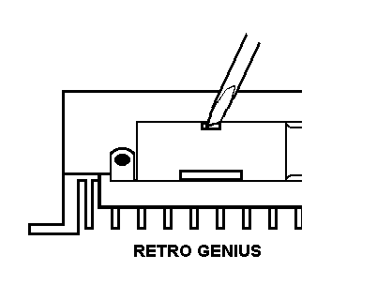
BACK OF GENIUS

- GENIUS is delivered with none of the jumpers configured, as shown in the drawing below.

- The required configurations are set by inserting the jumpers according to system requirements as follows:

C-1: When it is not inserted it enables the controller to work at 12 V; when it is inserted, it enables the controller to control 24-V batteries.

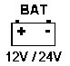

C-2: This is a function that is used only in display controllers or is activated afterwards; this enables a shunt to be fitted into the system that is connected to a battery to enable the maximum current of 100 amps to be read. This enables a power balance to be achieved and the maximum 2400-W power intake of the inverters to be checked that are connected directly to the accumulators.
With this configuration, the reading on the display is modified by substituting ‘IbatE’ for ‘IbatI’, so that the daily amp balances are also correct. If C-2 is not inserted, the current is read by means of the internal ammeter.
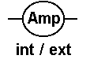

C-3: It enables the controller to work with an acid lead battery or with a liquid electrolyte battery when it is not inserted, and if it is inserted the controller can control sealed lead batteries or gel batteries.

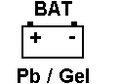

C-4: When it is not inserted, GENIUS controls the charge by means of an internal algorithm so as to check moment by moment the actual charge status of the battery installed in the system. If the jumper C-4 is inserted, the controller controls battery charge only by checking battery voltage values.

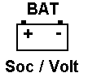

C-5: This is a function that is used only in display controllers or is activated afterwards. When C-5 is not inserted, the installer menu is displayed, so all the complete parameters of the system are available, subdivided into 12 submenus, which are very useful during the system installation phase. If C-5 is inserted, only the user menu is displayed, on the main page the message GENIUS will be followed by the symbol ‘-’ and by the controller’s maximum current capacity. The user menu consists of 7 submenus that provide the essential information on system operation.

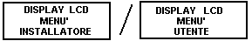
LCD DISPLAY MENU
USER
LCD DISPLAY MENU
INSTALLER

SUMMARIZING

The controller is delivered with the configurations 12V, internal ammeter, lead battery, SOC control charge status, 24h load output.

SUMMARY OF POSSIBLE SETTINGS FOR CIVIL 24H APPLICATION

JUMPER | NOT INSERTED | INSERTED
C-1 | 12V | 24V
C-2 | INT. AMP. | EXT. AMP.
C-3 | BATT. Pb | BATT. GEL
C-4 | SOC CONTROL | VOLTAGE CONTROL
C-5 | INSTALLER MENU | USER MENU
C-6 | ---------- | ----------
C-7 | ---------- | ----------
C-8 | ---------- | ----------

Note: The jumpers marked by the symbol “----------“ are used for applications such as the operation as solar street lights at night.

Configuration example: 24 V, internal ammeter, gel battery, control by means of SOC charge status, installer menu (see picture below)
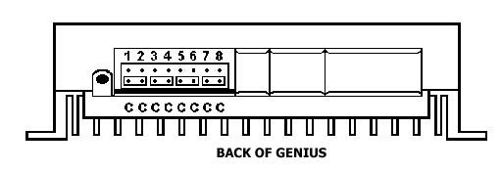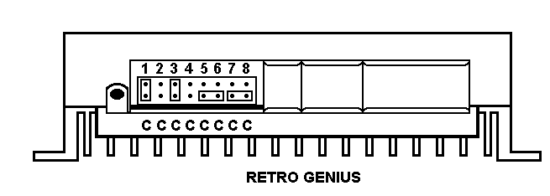

After setting the jumpers according to the above specifications, shut the lid protecting the jumpers

- Install GENIUS in a vertical position in accordance with the general notes on application and installation in chapter 2.

- Connect the battery to the terminals marked by the symbol “ , BAT “. Ensure correct polarity. After making this connection, the controller’s ‘BAT’ and ‘OUT’ LEDs will be both on with a yellow light for up to four seconds to indicate that the polarity of the connected battery is correct. GENIUS will then display battery charge status on the ‘BAT’ LED and output status on the ‘OUT’ LED.

WARNING

If the third ‘reverse polarity’ LED is on yellow DO NOT PROCEED with installation, disconnect the cables connected to the controller and check polarity (then proceed from point 3).

FAULT MESSAGES

- If during installation the BAT LED is green and flashes although no connection has been made to the input module, this identifies incorrect setting of the jumper C-1 that controls the 24V operating voltage of the controller: system at 24V while GENIUS is set at 12V, otherwise it indicates another auxiliary generator inserted into the system which has the ability to finish charging the battery.

- If during installation the BAT LED is on with a fixed red light it indicates either an incorrect setting of the jumper C-1, system at 12V while GENIUS is set at 24V or it indicates that the battery charge status is low, with voltage below 11,3V.

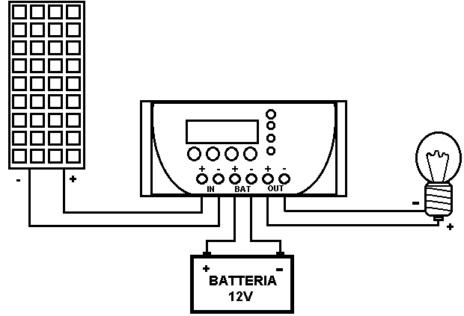
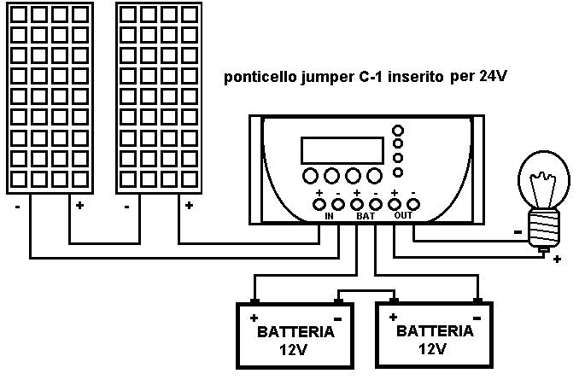
12V SYSTEM
Jumper C-1 inserted for 24V
24V SYSTEM

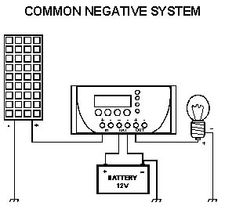

4 Connect the cables coming from the modules to the input of the controller that is marked by the symbol “,IN”, making sure that the polarity and configurations are correct (24V system, serially connected batteries and therefore serially connected modules), (12V system, single battery and therefore single module or parallel connection). After making this connection, GENIUS will switch on the internal charging circuit with a 10-second delay to prevent sparks on the terminals during installation.

5 Connect the load to the controller terminals that are marked by the symbol “ , OUT “, following the polarity indications printed on the container (there is a 15-second delay before the load is activated).

At this point the controller is already working in the 24-hour a day configuration.

LED MESSAGES

The BAT led displays the 5-step charge status of the battery as shown below:

COLOUR | BATTERY STATUS | ACTUAL CONDITIONS
Flashing green light | 95% - 100% capacity | charge at constant PWM voltage
Fixed green light | 75% - 95% capacity | Output on, load switched on
Fixed yellow light | 45% - 75% capacity | Output on, load switched on
Flashing red light | 30% - 45% capacity | Output on, load switched on
Fixed red light | 20% - 30% capacity | Output off, load switched off

A light of any colour that appears for 4 seconds at 4-second intervals indicates night, sunrise or sunset.

The OUT led provides information on the OUT section of the controller in the load part and may act as follows:

COLOUR | EFFECT
Fixed green | output on
Switched off | output off

A flashing green light that appears for 4 seconds at 4-second intervals indicates night, sunrise or sunset.

ALARM MESSAGE

- In addition to displaying the output status of the controller, the OUT LED reports any faults that are due to overloads and/or short circuits as follows:

COLOUR | MESSAGE | EFFECT
Flashing yellow light | Overload | Output off for 16 seconds
Flashing red/green light | Short circuit or  current above 50 amps per hour | Output off

- To reset the alarm arising from the short circuit, solve the problem and press the GENIUS switch on the top side of the controller.

SPECIAL FUNCTIONS

GENIUS has the innovative ‘REARM’ function that enables the user to manually restore the output by making it active if necessary and when the controller has interrupted the supply to the load because of insufficient charge (LED is on with fixed red light during day). In this case, it is sufficient to push the switch on the top of GENIUS to activate the output so the load is supplied and the LED changes from fixed red to flashing red to indicate alert status but with a quantity of power available down to the bottom battery collapse limit of 10.5V (21V per 24V battery). N.B. This function must be used only in the event of necessity. Prolonged use will lead to early deterioration of the accumulators.

5 NOCTURNAL, SOLAR STREET LIGHT

This section addresses the use of Genius for nocturnal applications, for use with a solar street light or for other applications in which one or more loads have to be optimised from sunset to sunrise.
Read the instructions carefully and follow them step by step in order not to cause incorrect connections or configurations that may create or penalise system performance.
HELIOS TECHNOLOGY is not liable for any damage or faults caused by poor installation and use of the product in question.
Then follow this procedure:

1 Configure the jumpers located on the back of the controller:

- Open the lid located on the back of GENIUS near the switch by using the tip of a flat screwdriver to lift up the top closing part, as shown in the drawing below;

BACK OF GENIUS

- GENIUS is delivered with none of the jumpers configured, as shown in the drawing below.

- Set configurations by inserting the jumpers according to system requirements as follows:

C-1: When it is not inserted it enables the controller to work at 12V; when it is inserted, it enables the controller to control 24-V batteries.

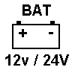

C-2: This is a function that is used only in display controllers or is activated afterwards; this enables a shunt to be fitted into the system that is connected to a battery to enable the maximum current of 100 amps to be read. This enables a power balance to be achieved and the maximum 2400-W power intake of the inverters to be checked that are connected directly to the accumulators.
With this configuration, the reading on the display is modified by substituting ‘IbatE’ for ‘IbatI’, so that the daily amp balances are also correct. If C-2 is not inserted, the current is read by means of the internal ammeter.

C-3: It enables the controller to work with an acid lead battery or with a liquid electrolyte battery when it is not inserted, and if it is inserted the controller can control sealed lead batteries or gel batteries.

C-4: When it is not inserted, GENIUS controls the charge by means of an internal algorithm so as to check moment by moment the actual charge status of the battery installed in the system. If the jumper C-4 is inserted, the controller controls battery charge only by checking battery voltage values.

C-5: This is a function that is used only in display controllers or is activated afterwards. When C-5 is not inserted, the installer menu is displayed, so all the complete parameters of the system are available, subdivided into 12 submenus, which are very useful during the system installation phase. If C-5 is inserted, only the user menu is displayed, on the main page the message GENIUS will be followed by the symbol ‘-’ and by the controller’s maximum current capacity. The user menu consists of 7 submenus that provide the essential information on system operation.

LCD DISPLAY MENU
USER
LCD DISPLAY MENU
INSTALLER

C-6: When it is inserted, Genius activates the sunset-sunrise function and thus keeps the load connected to it at ‘OUT’ for the entire day until sunset, after which it waits 15 minutes to prevent false start-ups due to car lights or poor visibility, and only after this time has elapsed will the load be switched on. This will remain lit until sunrise or until the controller disconnects the supply because battery charge status is insufficient (BAT LED is on with a fixed red light). This situation is repeated for each sunset-sunrise period. If C-6 is not inserted the sunset-sunrise function is inoperative.


C-7: When this jumper is inserted (C-6 NOT INSERTED) the lamp timer function is activated (standard setting is 5 hours but can be modified in the versions 15D and 30D or with the MAESTRO external display under heading ‘Lamp’), i.e. Genius works by switching on the load at sunset (after a 15-minute pause to prevent undesirable switch-ons) and keeps the load lit for a time that varies according to battery charge status. If it is 75% greater after the set time has elapsed, the load will be switched off at sunrise. If the charge is between 60%-75% the load will be kept on for another 3 hours and will then be switched off until the next sunset. If battery charge status is less than 60% the lamp will be switched off after the hours set by the timer have elapsed. Whatever the condition, the load cut-out protection against low batteries is current.


C-6 + C-7: When these jumpers are inserted they activate the lamp-pause-sunrise function. In other words, Genius switches on the load at sunset (after 15 minutes have elapsed to prevent undesired start-ups) and it keeps the load switched on for a time that varies according to battery charge status. If it is less than 60% the lamp will switch off after 5 hours (this can be set with external display or in the 15D and 30D versions) and will switch on again 2 hours before sunrise. If battery charge status is 60%-65% the load will remain constantly lit for the time set by the timer + 3 hours and will then be switched off for a time that depends on the duration of the night. It will be switched on again 2 hours before sunrise. If charge status is greater than 75% the load will remain switched on until sunrise because battery status will be efficient. Note that this situation generally occurs only in summer, i.e. when the nights are short and the days are long. If Genius calculates a pause of less than 1 hour the load will remain switched on until sunrise to prevent the load being switched on while still hot, which will shorten the working life of sodium-vapour lamps if they are used. Furthermore, whatever the situation, the load cut-out protection against low batteries is current.


- TO SUM UP: the controller is delivered with the configurations 12V, internal ammeter, acid lead battery, SOC control, output as load.

SUMMARY OF POSSIBLE SETTINGS FOR CIVIL NOCTURNAL APPLICATIONS

JUMPER | NOT INSERTED | INSERTED
C-1 | 12V | 24V
C-2 | INT. AMP. | EXT. AMP.
C-3 | BATT. Pb | BATT. GEL
C-4 | SOC CONTROL | VOLTAGE CONTROL
C-5 | INSTALLER MENU | USER MENU
C-6 | NO SUNSET- SUNRISE | SUNSET- SUNRISE
C-7 | NO 5-HOUR TIMER | 5-HOUR TIMER
C-6 + C-7 | NO PAUSE-SUNRISE TIMER | PAUSE-SUNRISE TIMER
C-8 | ---------- | ----------

Note: The jumpers marked by the symbol “----------“ are used for other civil 24-hour applications, or for camper versions only, depending on the battery.

Example of configuration with 24V, internal ammeter, acid lead battery, SOC control, installer menu, 5 hour + SOC lamp timer (see picture below):

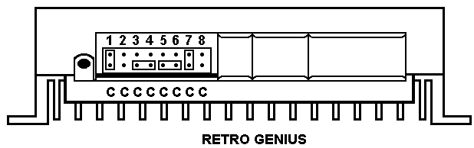
BACK OF GENIUS

After configuring the controller according to the instructions given above, shut the lid protecting the jumpers.

  - Install GENIUS in a vertical position in accordance with the general notes on application and installation in chapter 2.

3 Connect the battery to the terminals marked by the symbol “ , BAT “. Ensure correct polarity. After making this connection, the controller’s ‘BAT’ and ‘OUT’ LEDs will be both on with a yellow light for up to four seconds to indicate that the polarity of the connected battery is correct. After making this connection, Genius will switch on the internal charging circuit with a 10-second delay to prevent sparks on the terminals during installation.

WARNING

If the third ‘reverse polarity’ LED is on yellow DO NOT PROCEED with installation, disconnect the cables connected to the controller and check polarity (then proceed from point 3).
FAULT MESSAGES

- If during installation the BAT LED is green and flashes although no connection has been made to the input module, this identifies incorrect setting of the jumper C-1 that controls the 24V operating voltage of the controller: system at 24V while GENIUS is set at 12V, otherwise it indicates that another auxiliary generator inserted into the system which has the ability to finish charging the battery.

- If during installation the BAT LED is on with a fixed red light it indicates either an incorrect setting of the jumper C-1, system at 12V while GENIUS is set at 24V otherwise it indicates that the battery charge status is low, with voltage below 11,3V.

12V SYSTEM
Jumper C-1 inserted for 24V
24V SYSTEM

4 Install the cables coming from the modules to the controller input marked by the symbol “,IN“ taking care to comply with polarity and configurations (24V system, serially connected batteries and therefore serially connected modules), (12V system, single battery and therefore single module or parallel connection).

5 Connect the load or the lamp to the controller terminals that are marked by the symbol “ , OUT “ following the polarity indications printed on the container.

At this point the controller is already working in the configuration ‘nocturnal, solar street light’.

LED MESSAGES

The BAT led displays the 5-step charge status of the battery as shown below:

COLOUR | BATTERY STATUS | ACTUAL CONDITIONS
Flashing green light | 95% - 100% capacity | charge at constant PWM voltage
Fixed green light | 75% - 95% capacity | Output on, load switched on
Fixed yellow light | 45% - 75% capacity | Output on, load switched on
Flashing red light | 30% - 45% capacity | Output on, load switched on
Fixed red light | 20% - 30% capacity | Output off, load switched off

A light of any colour that appears for 4 seconds at 4-second intervals indicates night, sunrise or sunset.

The OUT led provides information on the OUT section of the controller in the load part and may act as follows:

COLOUR | EFFECT
Flashing green | output on
Switched off | output off

A flashing green light that appears for 4 seconds at 4-second intervals indicates night, sunrise or sunset.

ALARM MESSAGE

- In addition to displaying the output status of the controller, the OUT LED reports any faults that are due to overloads and/or short circuits as follows:

COLOUR | MESSAGE | EFFECT
Flashing yellow light | Overload | Output off for 16 seconds
Flashing red/green light | Short circuit or  current above 50 amps per hour | Output off

- To reset the alarm arising from the short circuit, solve the problem and press the GENIUS switch on the top side of the controller.

.

6 DISPLAY VERSION

GENIUS 15D and 30D versions are equipped with a 16-character LCD for two backlit lines to enable the user to monitor and modify by means of the 4 switches on the front of the controller a significant quantity of values and data displayed by the controller during operation. The display of all the system parameters is subdivided into 12 submenus and the keys ‘-‘ and ‘+’ on the keyboard underneath the display are used to move between them and to decrease or increase the permitted values during programming. If ‘prog’ is pressed for 3 seconds the programming mode of the displayed menu is accessed.
The submenus are displayed as follows:

The main menu displays: the GENIUS model and maximum current; in this example 30 amps. The symbol ‘-‘ between GENIUS and 30 A indicates that the user menu is active. The symbol ‘*’ indicates ‘day’. If it is replaced by the symbol ‘(‘ it indicates ‘night’. The second line shows the clock, “day” displays the days of use of the controller. In this menu the clock and the days of use can be programmed.

GENIUS-30A *
12:34:56 Day 0 0 0 1

The next menu displays: ‘Vmod’, i.e. module voltage; ‘IMod’, i.e. module current; and ‘Power’, i.e. the percentage of the module used, i.e. what percentage of the power supplied by the module is entering the battery. This value varies from 0 (open circuit) to 100% (charging circuit completely closed). Intermediate values indicate a PWM circuit with constant voltage, adaptation to the battery voltage on a load, or a protection condition on the modules side at nominal current. None of these values can be modified.

VMod IMod Power
16.0V 10.2A 72%

Pressing the ‘+’ GENIUS key calls up the battery parameters menu. ‘VBat’, battery voltage; ‘IBatI’, battery current; ‘SOCT’, battery charge status indicated as the power balance of the currents entering and leaving the controller expressed as a percentage. In applications where the load is directly connected to the battery or in which there is an auxiliary generator parallel to it, the SOC will not be correct because the controller will be unable to determine the currents except through the optional external shunt that has to be installed.

VBat IBat SOCT
14.5V 6.3A 100%
The letter T after SOC indicates control battery by means of a charge algorithm based on the actual SOC value. ‘SOCV’ indicates a charge based only on the voltage values. None of these parameters can be modified from the keyboard.

This menu displays the load values. ‘Vload’ indicates load voltage, ‘Iload’, load current, ‘Out’ possible output status, ‘on’ load switched on, ‘off’ load switched off. (In certain daily ‘RATE’ conditions that are other than 100% the Iload currents plus 1-2 amps might be read because of the great differences between modules voltage and battery voltage that may occur if charging has been completed).

VLoad ILoad Out
12.5V 2.1A On
No parameter in this menu can be modified.

This menu indicates the quantity of amps per hour/day entering (+ symbol) or exiting (- symbol) the service battery displayed in ‘AhDay’; and the daily power balance expressed by AhBal and defined as the percentage ratio between the AhDays and nominal set battery capacity. These data are updated twice a day: at sunrise to display evening and nocturnal consumption and at sunset to indicate the power generated by the modules and absorbed by the load. If the sign is ‘-‘ it indicates a negative power balance, i.e. current leaving the battery. If the sign is positive the balance is also positive. Obviously, if the loads are connected directly to the battery or there are auxiliary generators that transfer power directly to the accumulators without passing through the controller, the AhDay balance will not be correct (neither will the SOC) because no current passage will be detected unless the optional external shunt is used to connect to the service battery negative to have the correct balances. This menu also displays the colour of the ‘BAT’ LED expressed by the term ‘LEDB’ and indicated by 4 bars. Green LED 4 bars, yellow LED 3 bars, flashing red LED 2 bars, fixed red LED 1 bar. In the example the colour of the LED is yellow. No parameter can be modified in this menu.

AhDay AhBal LedB
+018A +009% I I I _
The menu shows the available amp hours in the battery expressed as ‘AhBat’ and the nominal amp hours indicated as ‘Nominal’. They are directly linked to ‘Soc’ (charge status) displayed by the controller in the menu described previously. Upon switch-on both items are 1000 Ah, i.e. there is a 100% Soc, which indicates a totally charged battery. It is therefore advisable during installation to set the actual nominal and available amp hours in the battery in order to obtain a correct indication of the power balance, and of the actual amp hours available in the battery and in the Soc. Even if these settings are not modified they do not influence the good operation of Genius because they merely inform the user of the conditions of the accumulators. Obviously, if there are external auxiliary generators or loads connected directly to the battery (such as camper applications), the reading of the parameters ‘AhBat’ and ‘Soc’ will not correspond to the actual values.

AhBat Nominal 12

00100 00100 Pb
The other parameters shown in the extreme right of the display show the configuration of the C-1 and C-3 jumpers, selection of 12V or 24V battery voltage, and type of battery: ‘Pb’ indicates a lead battery and ‘Gl’ indicates a gel battery. The ‘AhBat’ and ‘Nominal’ parameters can be changed from the keyboard.

The menu alongside displays the type of charging in progress and the time required to terminate it, in addition to the voltage value at the end of charging that has already been compensated on the basis of the temperature read by the controller. The type of charge is chosen independently by Genius according to actual battery charge status. This message may therefore appear on the screen: ‘Charge=’ ‘nrm’ for normal, i.e. buffer charge at 13.8 V at 25 °C, or ‘equ’ for equalisation, i.e. completed charge at a voltage value that is the same as 14.2 V at 25 °C, whereas if the battery has been greatly run down in the previous days, GENIUS will bring the accumulators to gassing by taking them to a voltage value of 14.8 V at 25 °C. This type of charge is indicated on the display by the term ‘Bst’ (not available if you use a gel battery). The timer will decrease minute by minute from the moment at which charge status is near 95%-100% and will stop when battery voltage is below the value of the set complete charge. At the end of the ‘equ’ or ‘Bst’ charging cycle GENIUS will return the charge to ‘Nrm’ normal conditions. Furthermore, the three load cycles can be modified manually and it is also possible to interrupt the power flow coming from the modules using ‘off’.

Charge = equ 14.1V

Timer = 62 m T+29°

The following menu enables the user to change the complete charge values for each ‘Norm’, ‘Equ’, ‘Bst’ mode. The modifiable values will be between 10.5 V and 15 V (values at 25 °C). It is also possible to modify the time, from 1 to 4 hours, during which the controller applies ‘Equ’ or ‘Boost’ charging. The value 0 disables both modes.

Norm=13.8 Eq=14.2

Bst=14.8 Time=1h

The following menu enables the user to modify the ‘Ldoff’, load disconnection voltage values and ‘Ldon’ load reconnection voltage values. The first parameter varies the voltage value (then translated into charge status) at which the controller cuts the output because the battery is low. This is thus the system’s minimum operating voltage. ‘Ldon’ modifies the voltage value at which the controller reconnects the load after disconnecting the users at the ‘Ldoff’ level because the battery was low. The modifiable values are between 10V-11V for ‘Ldoff’ and 12V-15V for ‘Ldon’. ‘Dout’ indicates the three digital outputs on the rear peripheral of GENIUS, on the opposite side of the jumpers. They are indicated by the display as high logic status ‘^’ or as low logic status ‘_’, depending on battery charge status and therefore the indications supplied by the ‘BAT’ LED. The correspondences are as follows: fixed or flashing green LED ‘-^’; yellow LED ‘^_^’; flashing red LED ‘^^^’; fixed red LED ‘^^_’; switched-off controller ‘_’. The example given here identifies a yellow LED situation; battery 45%-75%. These outputs can be used both as remote monitors and to manage controls of battery chargers, external generators or solar street lights with variable intensity light. In this menu only the on-off timer settings can be modified.

Ldoff Ldon Dout

11.3 V 12.4 V ^ _ ^

The following menu offers a timer inside GENIUS for programmed switching-on or switching-off at a set time. T-On sets switch-on time in hours and minutes. T-Off sets switch-off time in hours and minutes. Setting both timers at 24:00, as in the drawing alongside, overrides the timer function; and the controller works in the conditions preset by the rear jumpers. This screen also manages the ‘Lamp’ parameter used only in the nocturnal configuration, solar street light and corresponding to the timer for switching on the lamp from sunset as a standard time. All these parameters can be modified.

T-On T-Off Lamp
24:00 24:00 5h

The menu alongside displays the type of configuration and the C-6, C-7 and C-8 jumper functions used by Genius for special functions. This display can modify its indications in relation to the nocturnal or civil application. The controller will display the message ’24hrs’ for a civil output with disconnection of the load at the value previously set on ‘Lloff’. The display will show “⌋ - - - -“ when the sunrise-sunset nocturnal configuration is set. If the jumpers are setting as lamp timer the display will show “⌋-___ “. When the function sunset-pause-sunrise is entered the display will show “⌋-_⌋- “ All of the above parameters can be modified from the keyboard.

Jumper Set C8

24hrs Off

The last menu that Genius can display summarizes the main parameters of the system in a single screen. The display leaves out the decimal points and is compact and concentrated. It displays the electrical parameters of 11 subdivided indications as in the example alongside between brackets: module voltage (16.5 V), module current (7.6), battery voltage (13.7 V), battery current (1.6 A), current side (+, at accumulator input, - accumulator output), load voltage (13.6 V), load current (6.0A), PWM charge percentage (72%), increased duration of night, display once every four minutes, so when it displays 150, 600 minutes will have elapsed, i.e. 10 hours from sunset (during nocturnal operation the reading of the night duration after the timer can have the value 200 added to it), day-night indication (‘*’ day or ‘(‘ night), output status (“^” active or “_” off).

165 137 136 072*

076 +016 060 150^

7 EXTERNAL PERIPHERALS

On the rear side, GENIUS has a series of connectors that are used to interface the controller with one or more external peripherals. Behind the plastic wings in position A there is the connector that is dedicated to connecting the external display with the relative keyboard. In position B there is the serial output RS232; whereas in C there is a 9-pole connector that enables different devices to be connected, including the new series of ballasts for solar street lights with variable intensity light. The arrangement of the terminals of clamp C is set out below:

A
display
B
RS232
C
Peripheral
output

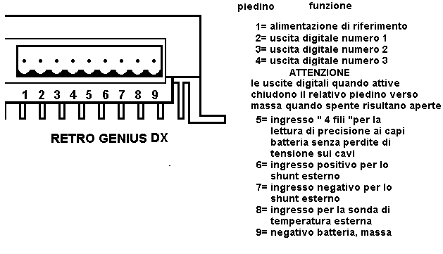
Pin Function
1= Reference supply
2= Digital output 1
3= Digital output 2
4= Digital output 3
WARNING
When the digital outputs are active they close the relative earth pin. When they are off they are open.
5= 4-wire input for precision reading at ba battery terminals without voltage lose ****on the cable.
6= Positive input for external shunt
7= Negative input for external shunt
8= Input for external temperature probe
9= Battery negative, earth

BACK OF GENIUS

TECHNICAL SPECIFICATIONS

Normal operating voltage | 12V / 24V |  | to be set from jumper C-1
GENIUS 15 max in / out current | 15A / 15A
GENIUS 30 max in / out current | 30A / 30A
Volt resolution | 0,1V
Ampere resolution | 0,1A
Measured values tolerance | 1,5 %
Connecting clamps size | 16mm²
Body dimensions | 206 x 115 x 44mm
Weight (basic version without display) | 560g
Weight (version with display) | 620g
LEDs OFF / ON self-consumption | 16mA / 34mA
Lighted display self-consumption | 33mA | (15s lighting after pressing any key)
MAX voltage difference between IN - BAT – OUT | 0,6V at full power, typical 0,2 – 0,4V
Technology | SMD solid-state with MOSFET
Charging Mode | serial
Charging time equ, bst | 1 hour
End of charge algorithm | PWM at steady voltage
Software owner | Helios Technology Srl
Temperature adjustment coefficient | -6mV/°C / cell (25°C)
Selectable type of battery | lead acid or hermetic gel |  | adjustable with jumper C-3
Operating temperature | from -20C° to +60C°
Minimum operating voltage | 9V
Overload protection at the “OUT” load output | Electronic to nominal current and against short circuit
Electronic protection switch-on time | 10ms
Overload protection at the “IN” module input | electronic PWM to nominal current
IP protection degree | IP22

VOLTAGE THRESHOLDS VALUES PRESET AT 25°C
(VALUES MUST BE DOUBLED FOR 24V SYSTEMS)

Load cut-off | Ldoff | 11,3V | Adjustable in GENIUS 15D & 30D versions
Load RESET | Ldon | 12,5V | “ “ “ “ “
Buffering charge | norm | 13,8V | “ “ “ “ “
Equalization charge | equ | 14,4V | “ “ “ “ “
Deep charge | bst | 14,8V | “ “ “ “ “
The above thresholds will be automatically modified by the inner temperature-compensation function

STANDARD EXTERNAL INTERFACES

- 8 jumpers which can be easily positioned by the customer
- RS232 communication port
- Standard connector for the external display (Maestro)
- External peripheral for the “4 wires” connection and inputs for the readings of the external shunt
- Input for an external temperature probe
- Digital ON-OFF outputs for monitoring or remote-driving the system, other auxiliary generating sets, etc

DISPLAY MONITOR

GENIUS basic version: | 2 multicolor LEDs + 1 yellow LED indicating a reverse polarity
GENIUS display version: | 2 multicolor LEDs + 1 yellow LED indicating a reverse polarity +  1 backlighted 16 characters x 2 LCD display, updated 6 times per second +  4 multifunction keys

FUNCTIONS AND APPLICATIONS

Civil, 24h:
- Load on/off
- Rearm function, forced switch-on of load with insufficient battery
- Insertion of external shunt to read currents up to 100 amps by C-2
- Overriding of algorithm of charge status for controlled operation only with voltage modifiable by C-4 jumper

Nocturnal, solar street light:

- Operation from sunset to sunrise (C-6)
- Nocturnal operation with timer + extra time depending on battery SOC (C-7)
- Nocturnal operation with timer + switch-on 2 hours before sunrise

DISPLAYS AND DISPLAY SETTINGS

- Type of controller, day/night, clock, days of operation
- Modules voltage, modules current, percentage of use of power module
- Battery voltage, battery current, charge status
- Load voltage, load current, output status
- Input or output day amp-hour capacity, power balance, status of battery bars
- Available battery amp-hour capacity, nominal battery amp-hour capacity, indication of nominal voltage, type of battery
- Type of current charge, PWM voltage in relation to temperature, remaining time to normal charge
- Voltage values for normal charge, equalization, deep boost, time per cycle
- Voltage values at load disconnection, load reconnection, status of digital outputs on rear peripheral.
- Timer for programming switch-on at preset times, timer modification for nocturnal switch-on of street lamps
- Jumper configuration for domestic function or nocturnal function in graphic form.
- Summary of main parameters of system including duration of night.

Helios Technology reserves the right to make modifications to this manual without notice to improve the GENIUS controller performance.

